# Éléments de correction pour le TD3 partie sur les AVL

## Question 1: draw two AVL trees of height 4 one which holds as few elements as possible, one which holds as many elements as possible.

1. As many elements as possible

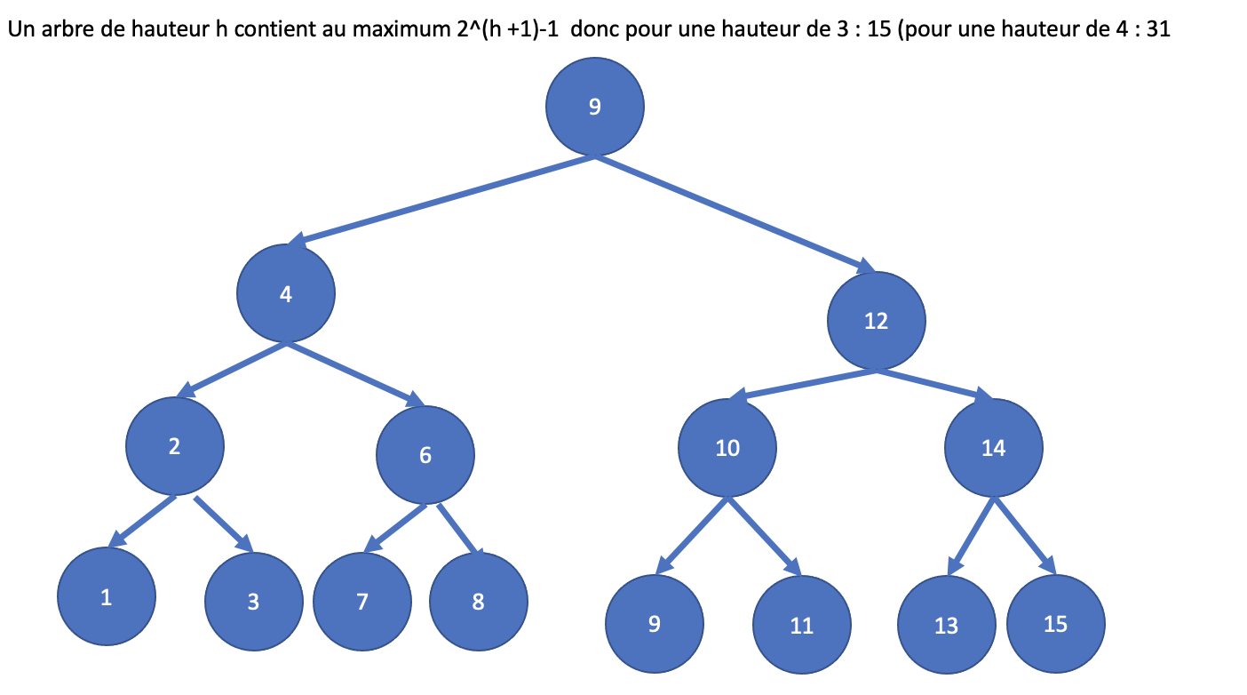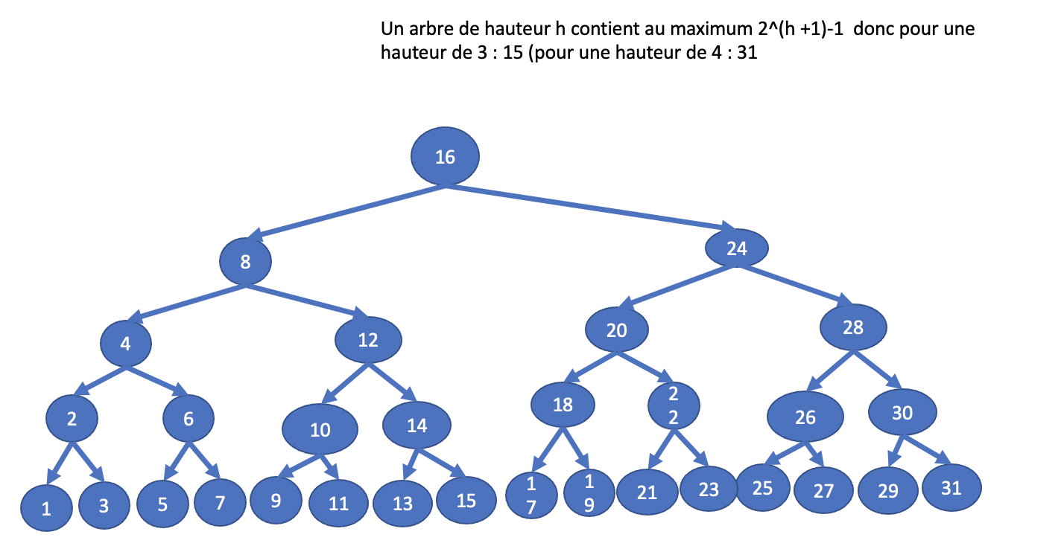

1. as few elements as possible

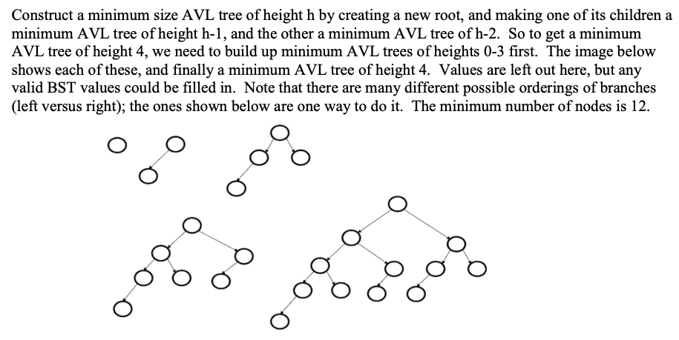

Figure 1 : extrait de https://courses.cs.washington.edu/courses/cse332/11wi/sections/week4/solutions_week4.pdf

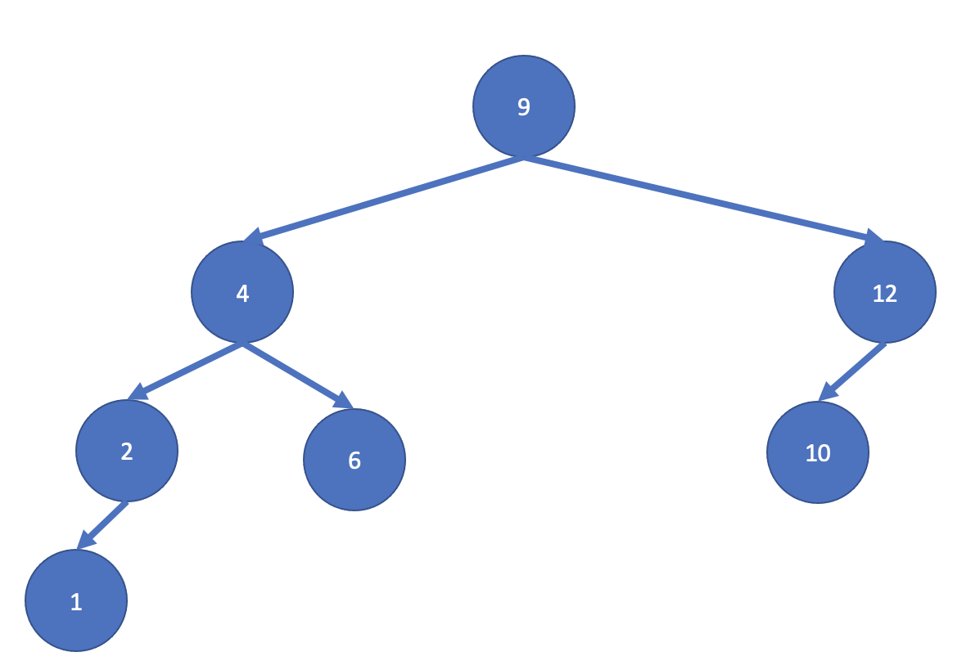 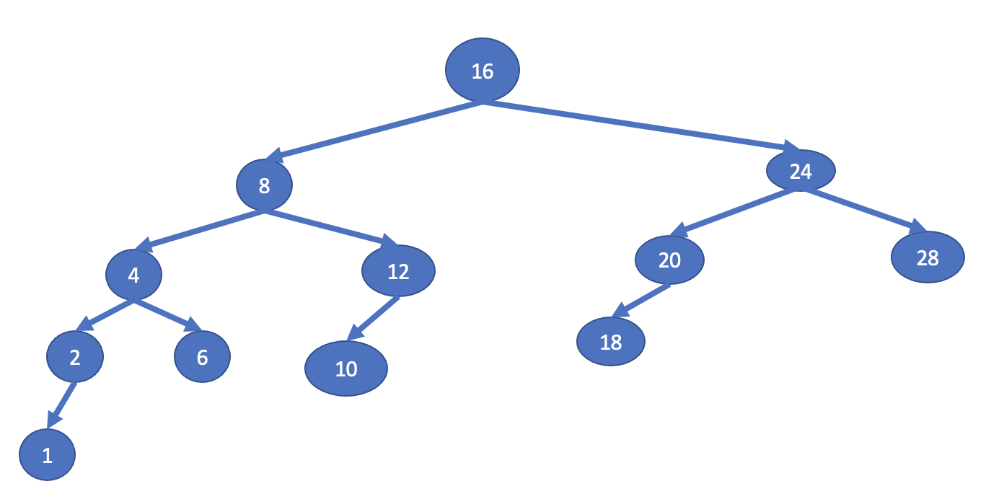

## Question 2: draw the AVL tree resulting from inserting the following integer value inside an initially empty AVL tree: 9, 4, 1, 3, 2, 8, 10, 6, 5, 11, 7

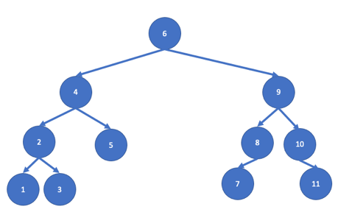6

|_ 4

| |_ 2

| | |_ 1

| | |

| | |_ 3

| |

| |_ 5

|

|_ 9

|_ 8

| |_ 7

| |

| |_

|

|_ 10

|__

|

|__ 11

## Question 3: Given the ordering, we could remove all the elements from the previous tree such that no re-balancing is needed.

## 7,11,10*,*1,3,9,4,5,2,8,6

**Une sequence possible:**

*************** REMOVE 7

*************** REMOVE 11

*************** REMOVE 10

*************** REMOVE 1

*************** REMOVE 3

*************** REMOVE 9

*************** REMOVE 4

*************** REMOVE 5

*************** REMOVE 2

*************** REMOVE 8

*************** REMOVE 6

**Une autre sequence:**

remove 11

remove 1

remove 7

remove 3

remove 8

remove 5

remove 10

remove 2

remove 4

remove 9

remove 6

## Question 4: give the minimum number of nodes (elements) of an AVL of height 10

If height of AVL tree is h, **maximum number of nodes can be 2h+1 – 1**.

**Minimum number of nodes** in a tree with height h can be represented as:

N(h) = N(h-1) + N(h-2) + 1 for n>2 where N(0) = 1 and N(1) = 2.

height = 0 : 1

height = 1 : 2

height = 2 : 4

height = 3 : 7

height = 4 : 12

height = 5 : 20

height = 6 : 33

height = 7 : 54

height = 8 : 88

height = 9 : 143

height = 10 : 232